2018 Advisory Board
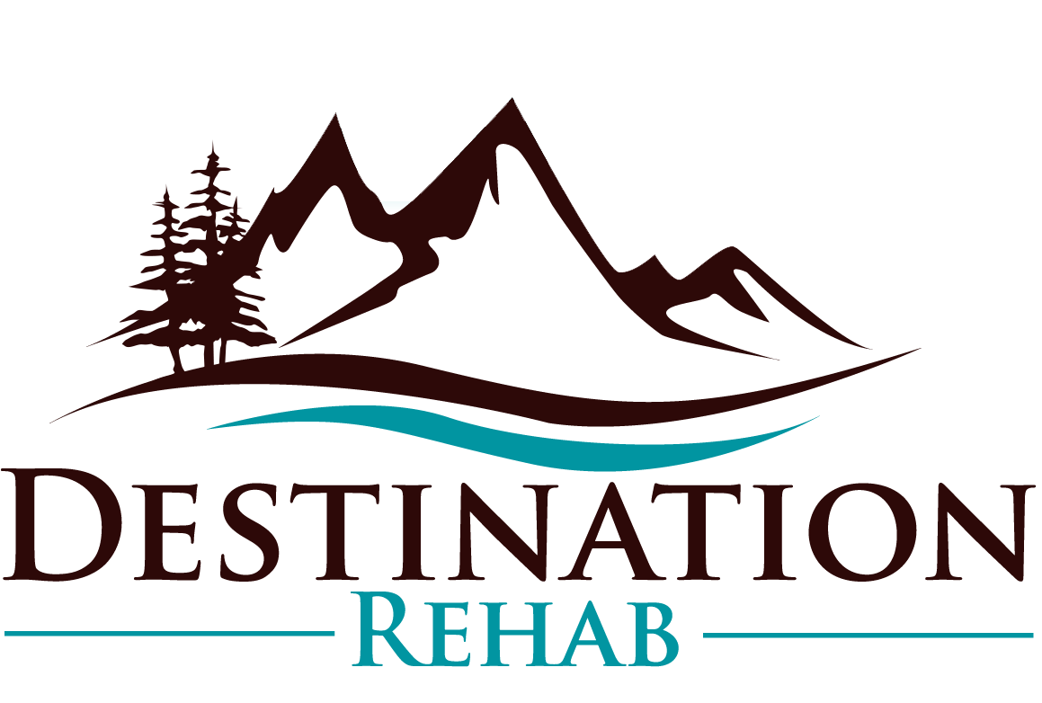

“One can never consent to creep when one feels an impulse to soar.” – Helen Keller

Position Description
The Destination Rehab 2018 Advisory Board is a one-year commitment, and the primary functions are to provide expert advice, targeted feedback, and to expand our community partnerships. The Advisory Board also functions as part of the process many people take in becoming a member on our Board of Directors. This is an opportunity to work closely with our founder, get to know our team, and contribute to our growth as a new organization.

Each council member will be featured on our website for their contribution of time and expertise. Please read the detailed description below and use the contact info below with questions or to submit your name for consideration. Thank you!

Advisory Board Member (Jan. 2018 – Dec. 2018)
4 open spots
- Attends three (3) board meetings in 2018 to review and discuss primary organizational goals and outcomes.
- Available to meet with the Executive Director and Board President an additional three (3) times throughout the year to give targeted feedback regarding specific initiatives.
- Represents the values and mission of Destination Rehab in the community.
- Identifies members of the Bend and Central Oregon community who may serve as community business partners and corporate sponsors.
- Actively searches for permanent members for Board of Directors.
- Commitment to sharing Destination Rehab announcements and news via social media and email platforms.

Join our team!
Contact Carol-Ann Nelson
541.241.6837 or carolann@destinationrehab.org

